CSCI445 Final Project Report

Participant: He Huang, Zixin Ding

Readme:

You might edit the goal location and goal shelf in init function in finalproject.py. However, we assume starting theta is 0. Please remember to use the pyCreate2 folder we have submitted, since we added a function for get the location of arm in order to handle the rotation of robot once it reaches the goal.

Algorithm:

Locomotion: We have implemented particle filter for robot localization, rrt for path finding and obstacle avoidance. For the localization part, we use odometry to track the position of robot, also for each movement we update particles’ position. And for each 3 particles, we resample particles and gain estimate position. And we compare the estimate position with odometry position, if the difference is in certain range, we replace estimated information in odometry. And for the last position, we design a slow mode for more accurately go to the goal location with slower speed and more precision check. Also we have sonar error check for resampling process, if the the distance we get on map is out of sonar sensor range, we will do resampling on next valid waypoint.

Arm grab:

Performance:

We have done all the parts.

The robot won’t hit the wall during our tests.

The accuracy to reach goal location is within 5 cm.

During the multiple runs, the particle filter might generate wrong estimate location, since we resample too frequently given certain rrt paths. However, this is understandable, since some waypoint of rrt path might lead to particle filter to stuck in mirror position.

Screenshot:

Locomotion:

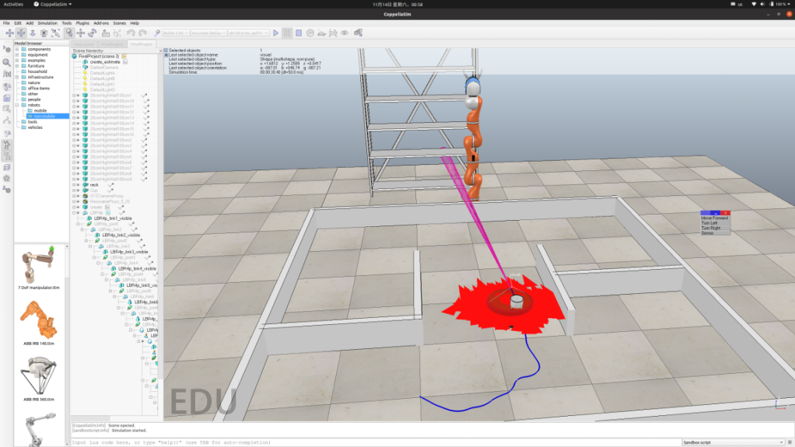

Goal Reached and Cup Grab:

